Project report

Date of arrival at the recipient:  Please enter your text here. | Recipient country:  Please enter your text here.
Region / Town:  Please enter your text here. | Institution:  Please enter your text here.
Contact person for queries:  Please enter your text here. | Mail address contact person:  Please enter your text here.

1. Where is the material used?

Please be as specific as possible about the location, size (beds, staff, etc.) of the facility where the material will be used (size, location, region, number of staff, number of patients per year, department if applicable). Please enter your text here.

2. How does the material improve the health situation for local people?

How does it improve treatment options? Can more people be treated? Will the treatment of certain diseases be improved? Please enter your text here.

3. What is the average length of stay of a patient? (to be filled in by hospitals only)

Please enter your text here.

4. Testimonials: Please describe in 1-2 sentences how the medical equipment from Switzerland has specifically helped. Ideal would be a testimonial from:
- Physician / doctor or nurse / nurse.
- Adult patient
- Child patient

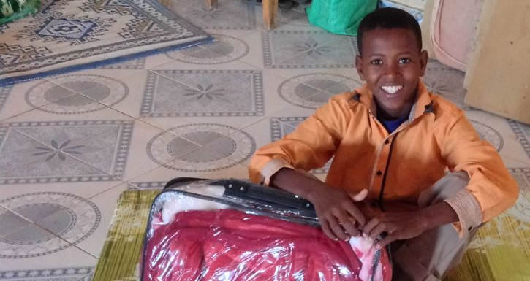
Example: "I love the new mattress because now I don't have to lie on the floor in the hospital anymore". (Jérémie, 8 years, hospital Somalia, was sick with cholera).

(please send pictures in high resolution separately!)

Please enter your text here.

5. Was the delivery of the relief goods reported in the media? Was the receiving institution upgraded in the public's perception?

Please enter your text here.

6. What did not go so well in terms of the delivery of relief supplies? What should be improved?

Please enter your text here.

Declaration of consent / data protection:

We hereby declare that the above-mentioned persons and institutions agree to the publication (will be published on: www.https://www.aide-assistance.ch/ social media like facebook, instagram, LinkedIn and twitter) of the data and images mentioned in this report.

Please enter your text here.

Place, date Signature / stamp

Thank you very much for filling out the form!

Please send the completed report with photos to:
info@aide-assistance.ch and
andreas.link@aide-assistance.ch

